Domayne’s Formica Dining Set

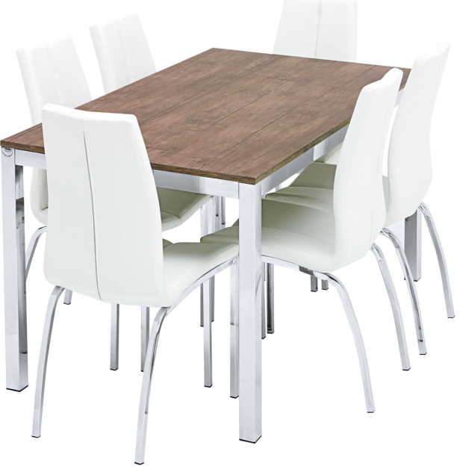

|  |
| --- |
| **DESCRIPTION** |
| Domayne introduces stylish Formica dining set with a rich wooden finish the set of tables and chairs is perfect to create the perfect look for family gathering. The rich stainless steel with wooden plank on top gives you feeling of happiness. Perfect for you and your family. |

|  |  |  |
| --- | --- | --- |
| **Price** | **1350$** | |
| **Dimensions** | **Table H** x **W** x **L** | **45in x 40in x 55in** |
| **Chairs H** x **W** x **L** | **31in x 20in x 30in** |
| **Features** | **Six Chairs and One Table with plank on steel top provide a helping hand to lift heavy objects and cutting edge durability.** | |
| **Finished** | **Wooden Touch** | |
| **Available in** | **Silver, Brown and Gold** | |